Git – HQL OUTPUTS

Name : G.S.R.Hemanth

Superset id : 6124988

* **Implement git ignore command to ignore unwanted files and folders**

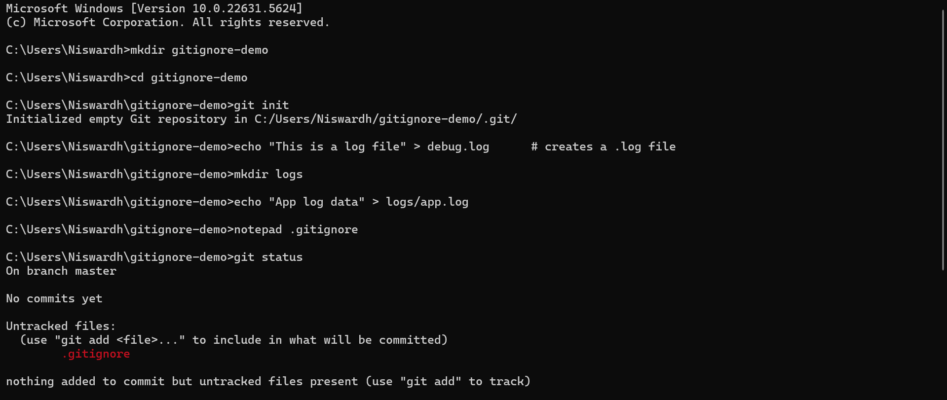

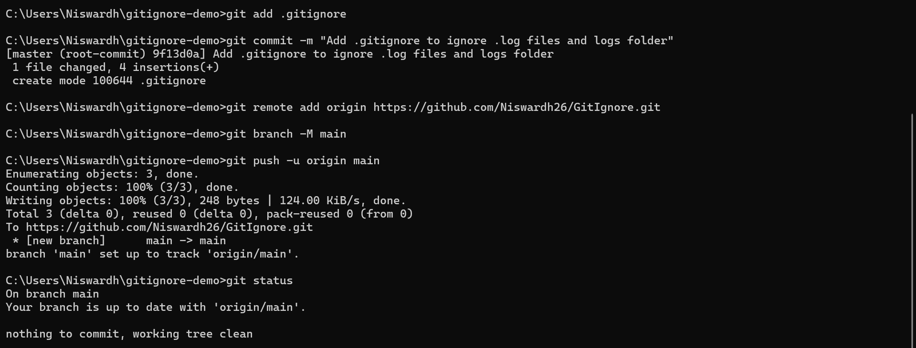

* **Construct a branch, do some changes in the branch, and merge it with master (or trunk)**

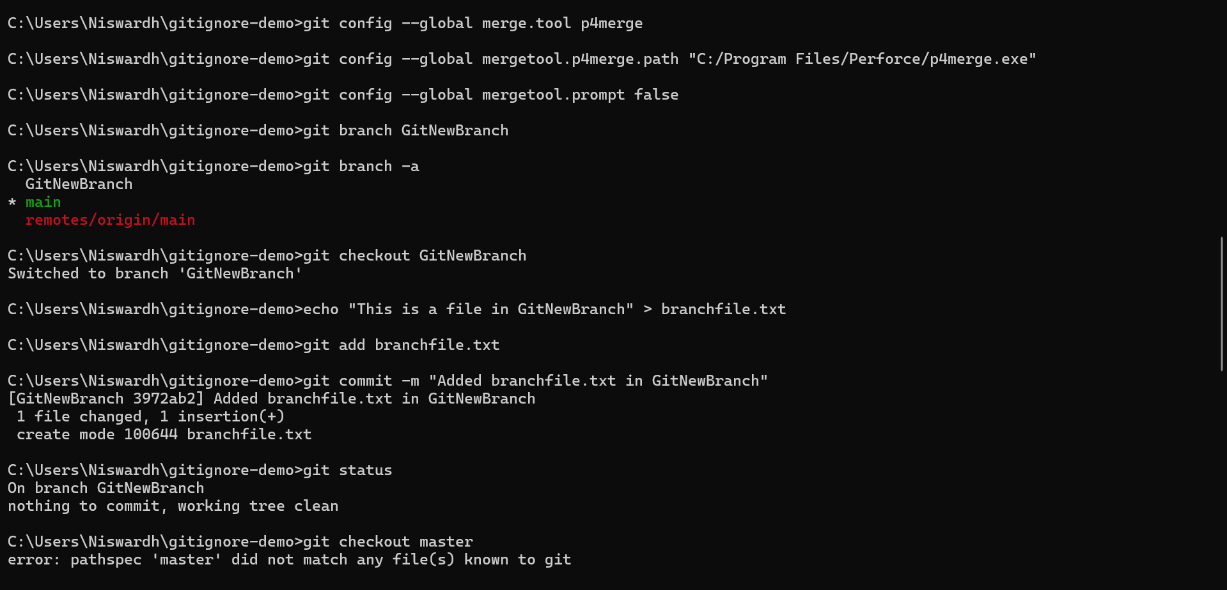

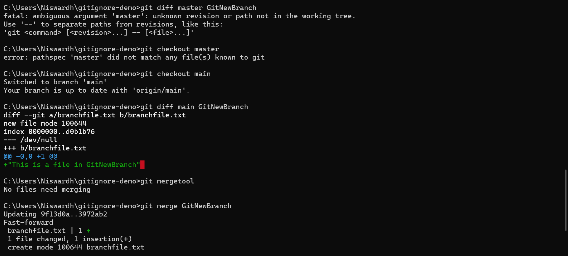

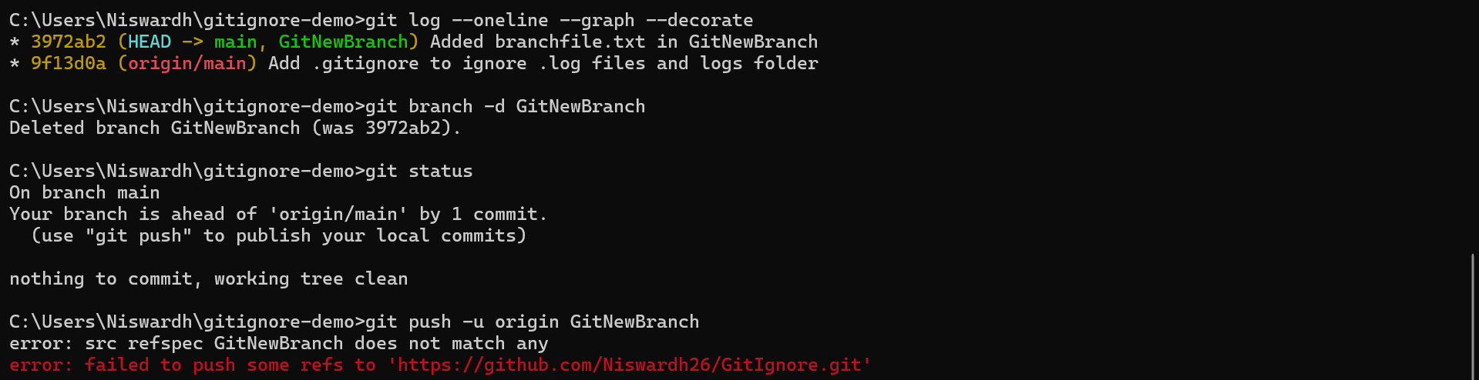

* **Implement conflict resolution when multiple users are updating the trunk (or master) in such a way that it results into a conflict with the branch’s modification.**

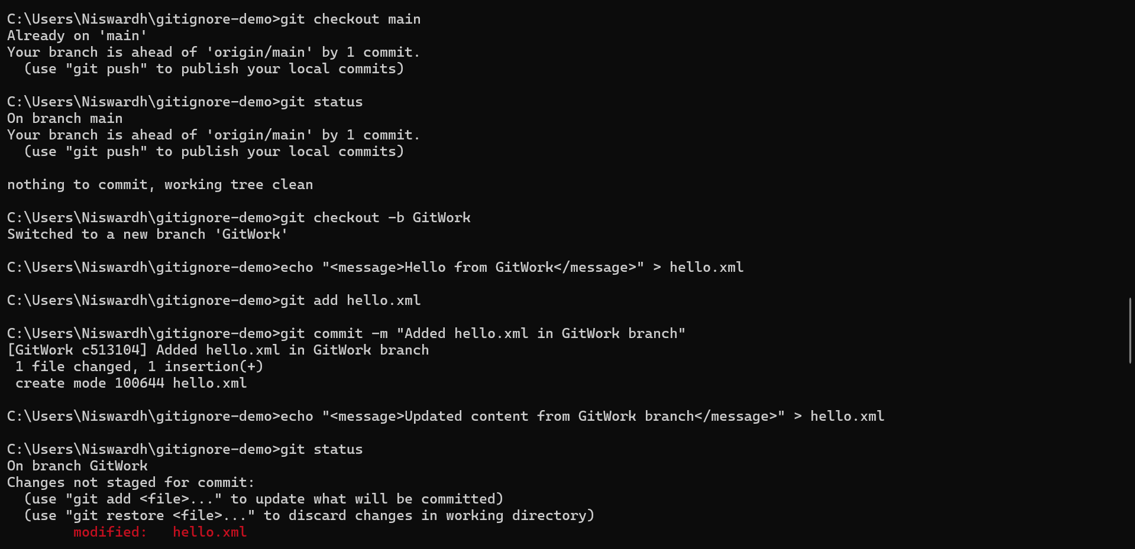

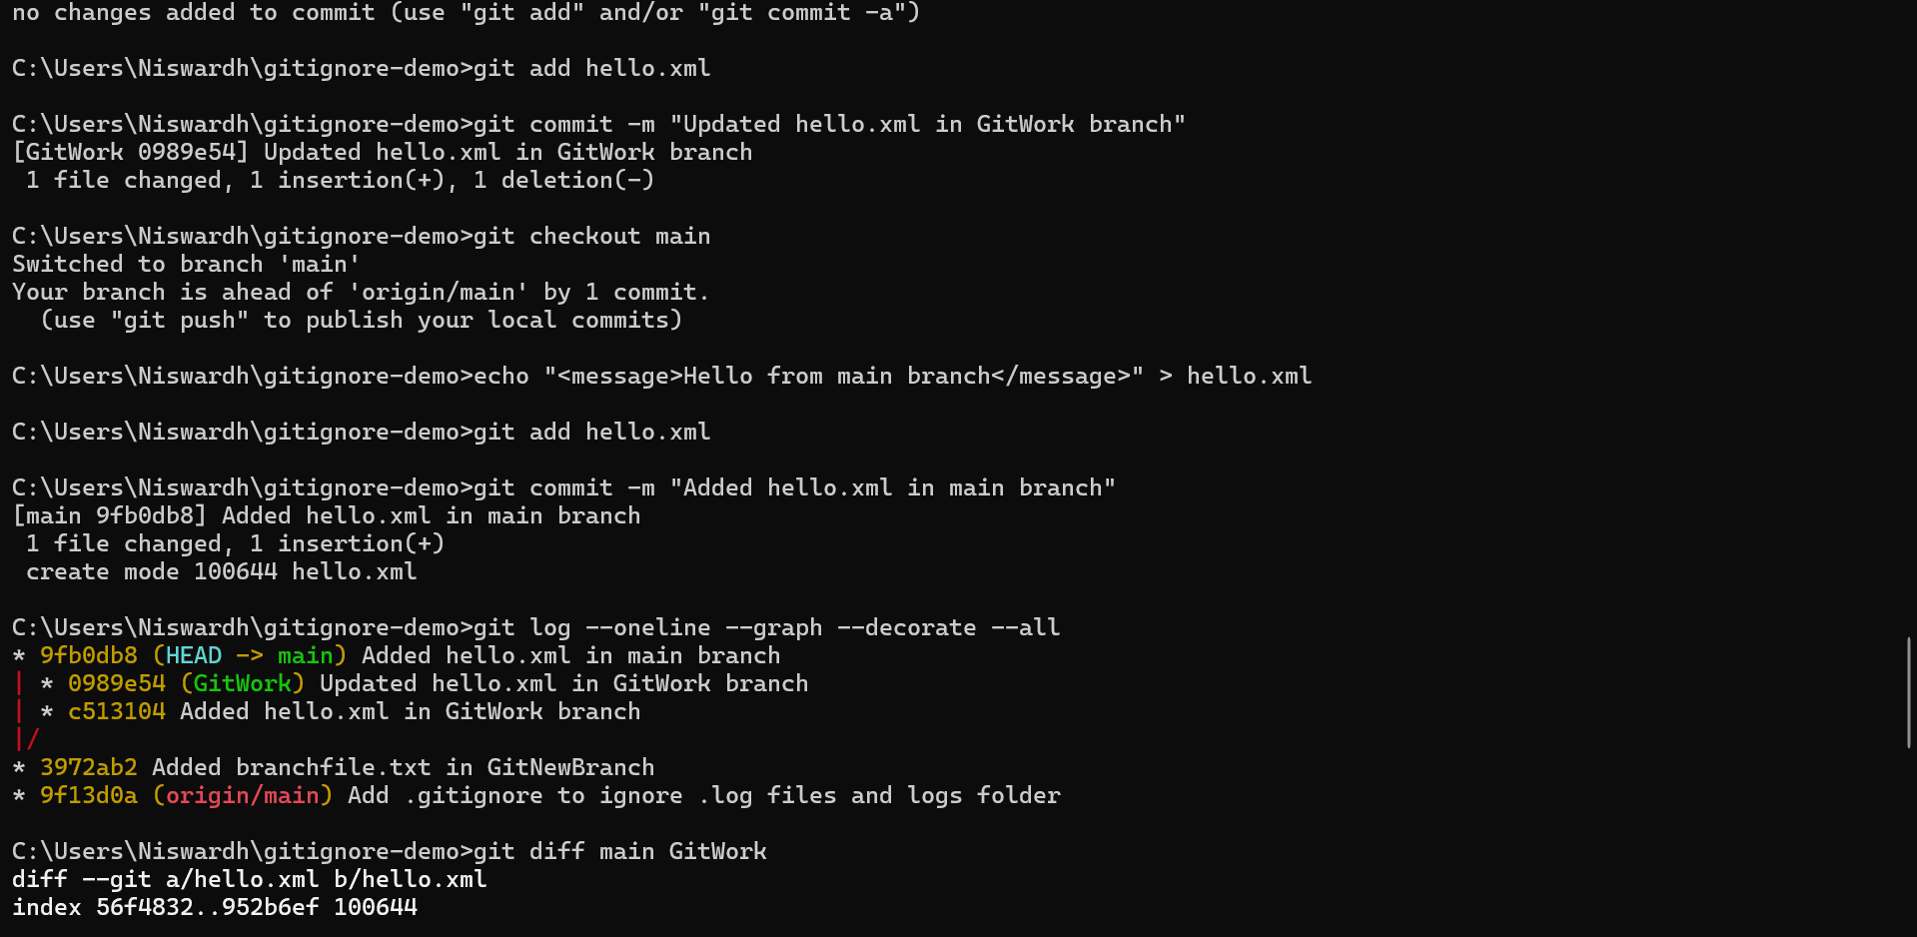

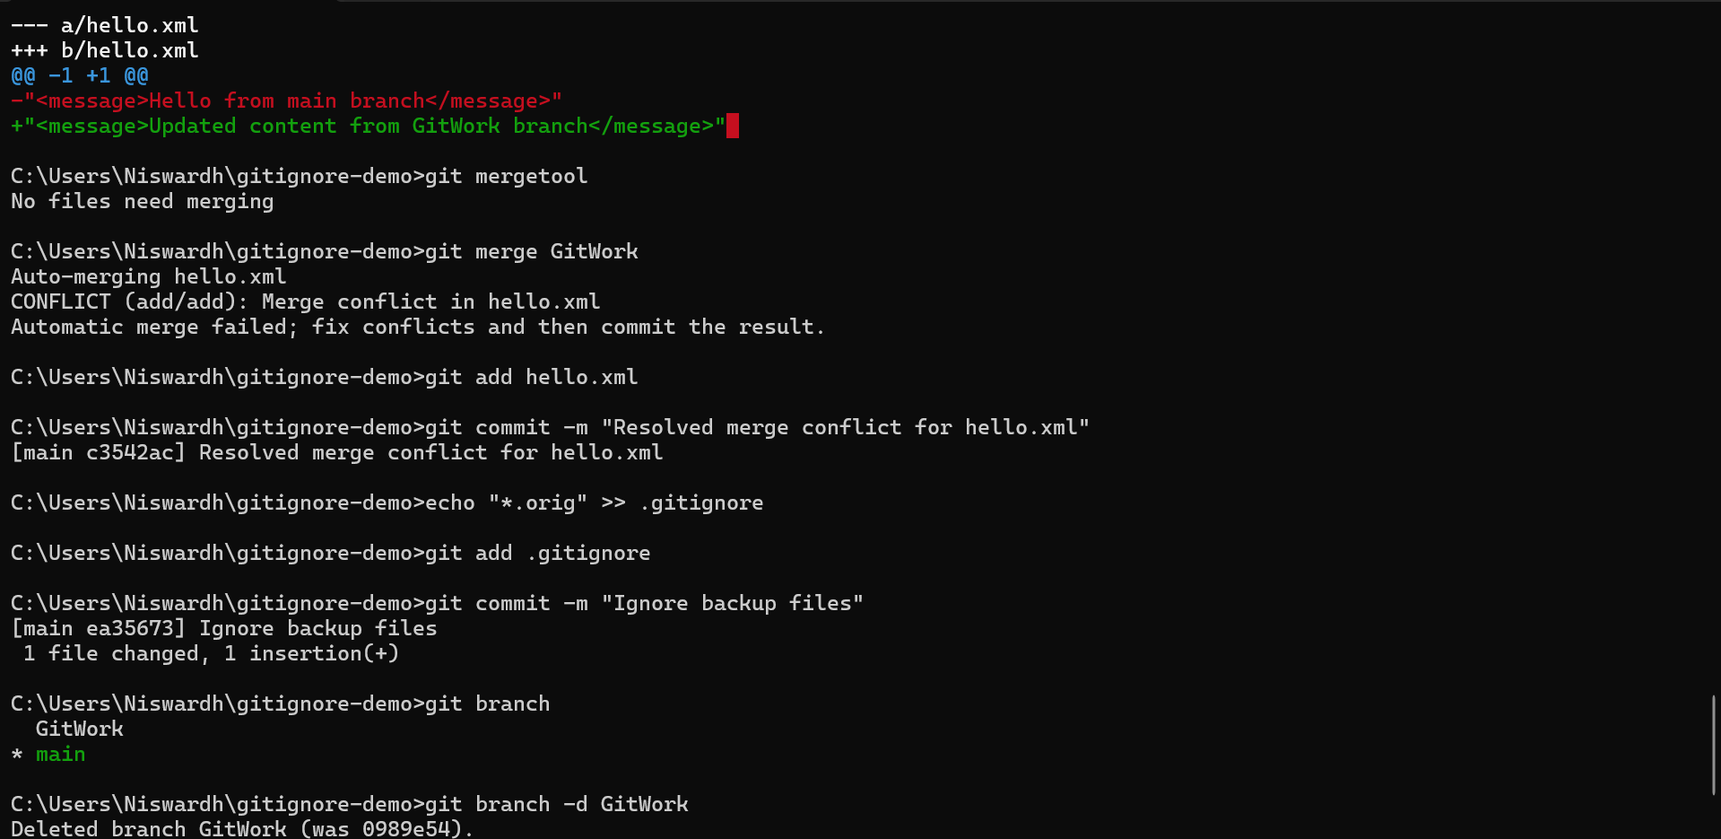

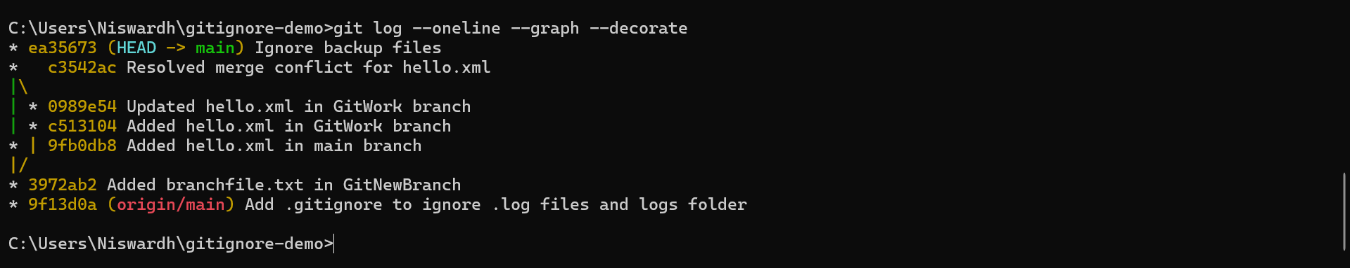

* **Execute steps involving clean up and push back to remote Git.**

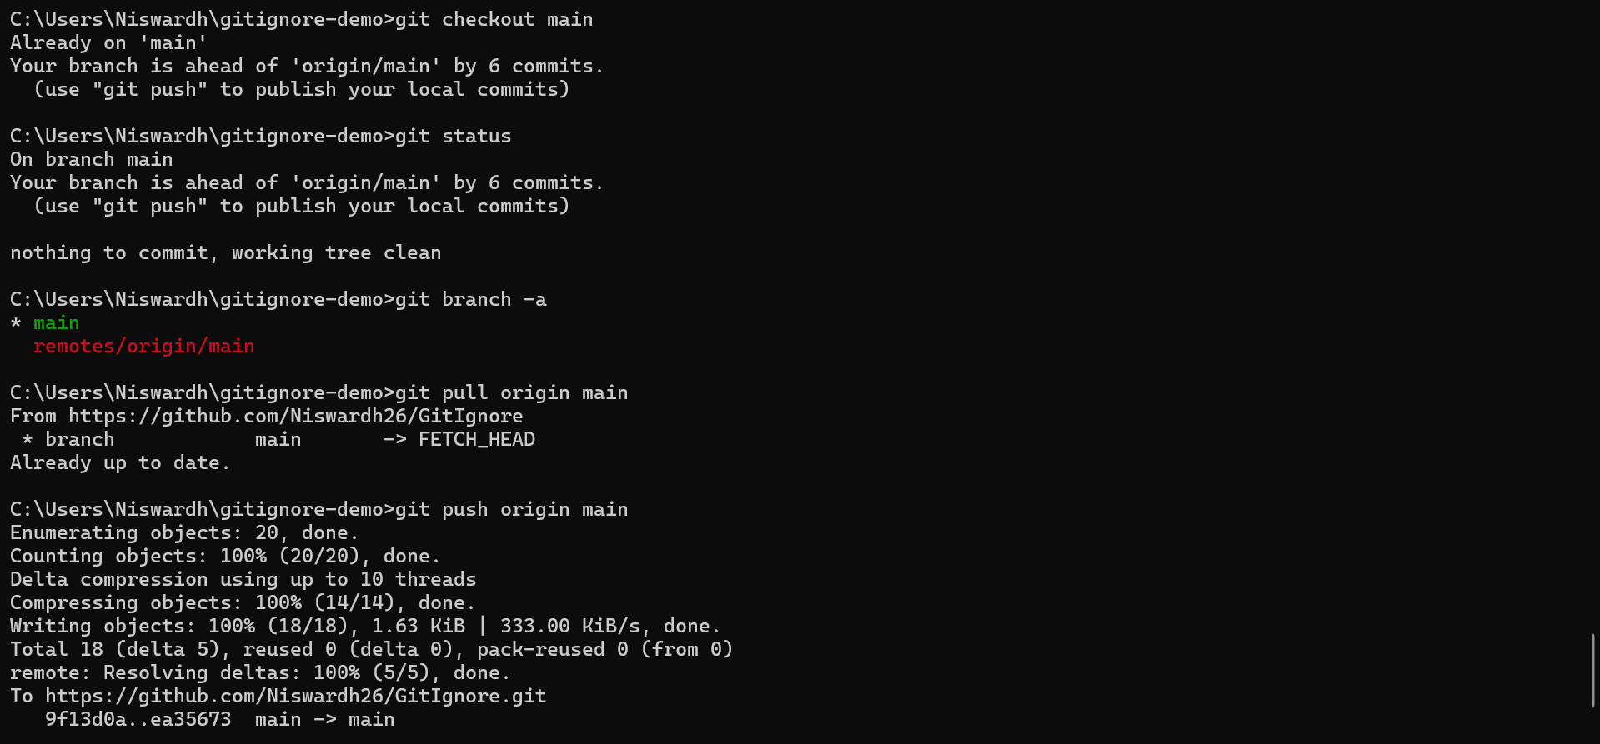

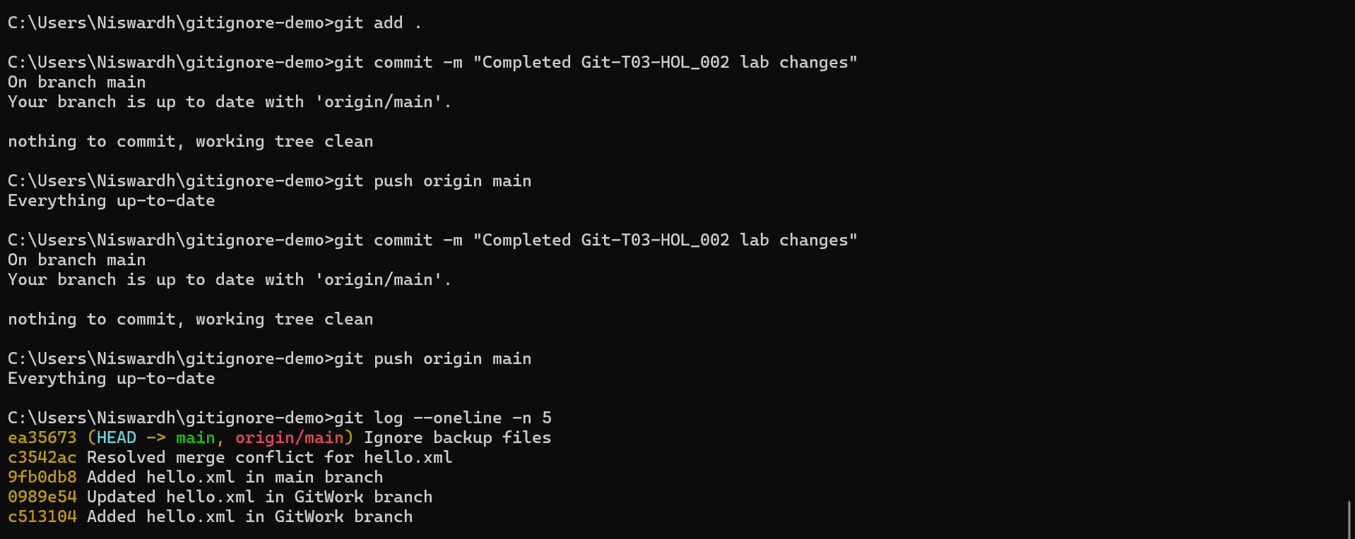

**Git Repository**

